User Guide:
Salesforce End of Tenancy

Version History
Version | Description of Change | Author | Date
0.1 | First Draft | Nikki Papenfus | 05/12/2023

Table of Contents
1. [Title] 3
1.1 [Subtitle] 3
2. Overview 4
2.1 The overall EOT process in Salesforce. 4
2.2 Where each of the teams’ responsibilities lie within the EOT process. 4
2.3 Where does the End of Tenancy Fit in? 5
3. How to Create an EOT 6
4. Looking at the EOT 6
4.1 Upload Documents 7
4.2 Task list 7
4.3 Chatter 7
5. End of Tenancy Tasks 8
5.1 Task Statuses 8
5.2 How to find which tasks need to be completed 8
5.3 The Task at a Glance / Task Overview 9
5.4 Starting a Task 10
5.5 Completing a Task 10
5.6 Setting Tasks to N/A 12
5.7 Reopening a Closed Task 13
5.8 Delays & Overdue Tasks 13
5.9 Completed task 13
6. How to cancel or close an EOT 15
7. Reports 15
8. Functionality for EOT owners: 15
8.1 Approving a request to cancel or close an EOT. 15
8.2 Identifying EOTs at risk 15
8.3 Void cost & KPI report. 15

[Title]

[Subtitle]

Text to add. (Arial 11)
Screen shots added where needed.

Overview
What is EOT
On creation of a void, phases and tasks are generated. An estimated start & end date is calculated for each task.
Each task is assigned to a team.
Estimated dates (& unit available date) are recalculated as preceding tasks are completed & as key information (such as PVI & FV dates) are captured or updated.




The overall EOT process in Salesforce.
What is phase
What is task
Teams are responsible for tasks

Where each of the teams’ responsibilities lie within the EOT process.
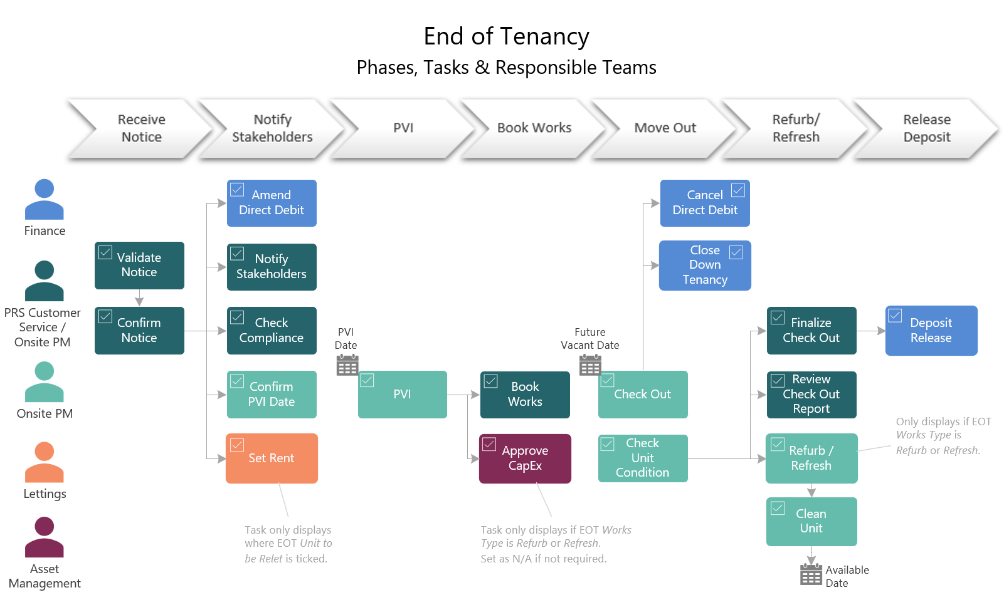

Where does the End of Tenancy Fit in?
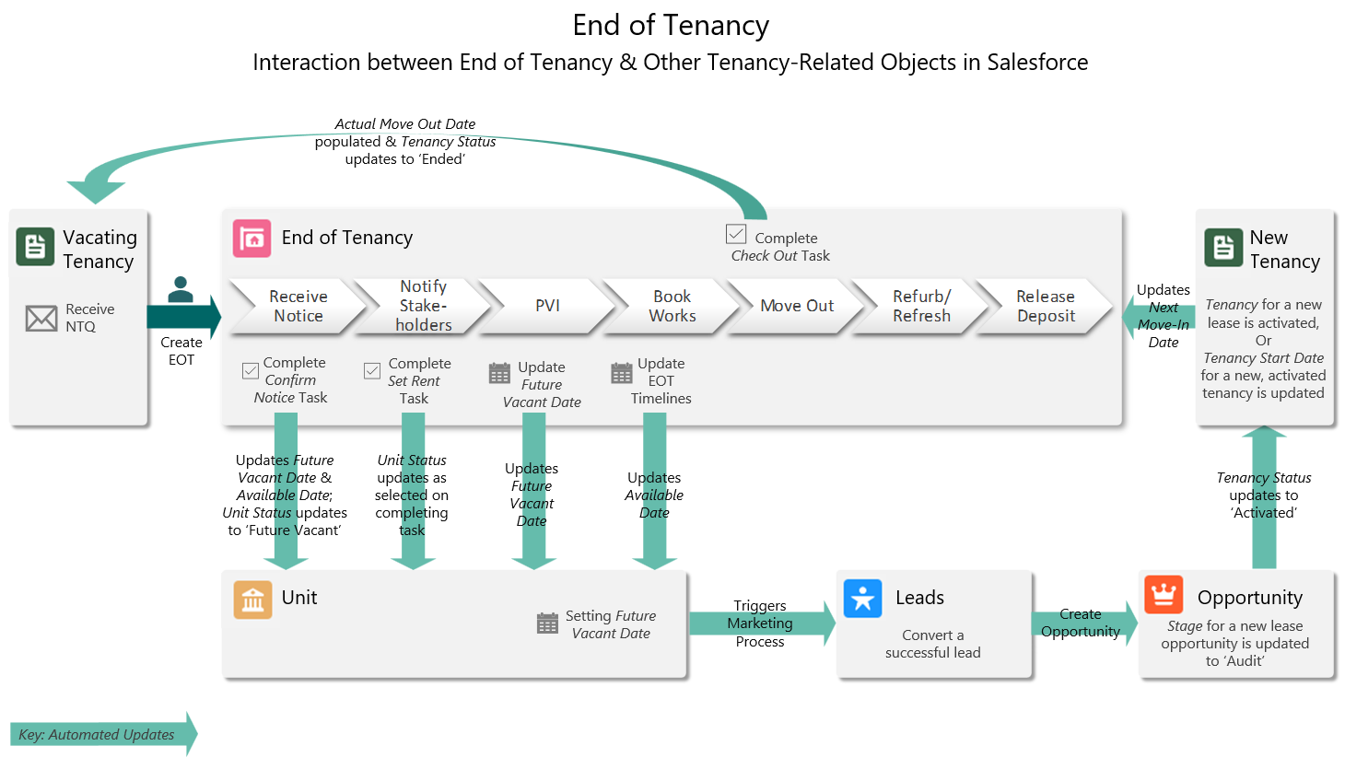

How to Create an EOT

Looking at the EOT
Phases close automatically. Phases automatically close once all underlying tasks are complete.
The EOT closes automatically.
Key EOT fields:
FV Date, PVI Date, Works Type [refurb/refresh/ approve capex], Sale [ seen by xxx] & Unit to be Relet [set rent]
FV is confirmed
PVI date is confirmed
Edit FV date -> reopen DD
Available date & completion date calculated automatically

Next Move In Date | No
Available Date | Calculated
Completion Date | Calculated
PVI Completed Date | Calculated
Deposit Return Date | Calculated
Works Start Date | Calculated

Upload Documents
- NTQ and any emails from the tenant
- Deposit Return Instruction (DRI)
- Check Out Report

Task list

Chatter

End of Tenancy Tasks

Task Statuses
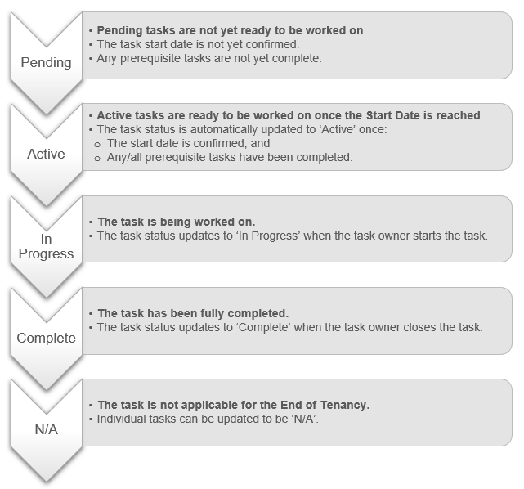

How to find which tasks need to be completed
Tasks appear in user’s task list based on the actual start date; not based on current phase.

The Task at a Glance / Task Overview
Task Status: Active tasks are ready to be worked on once the start date is reached; see above.
Target End Date:
Date by which the task should be completed.
Start Date: Date when work should begin on the task.

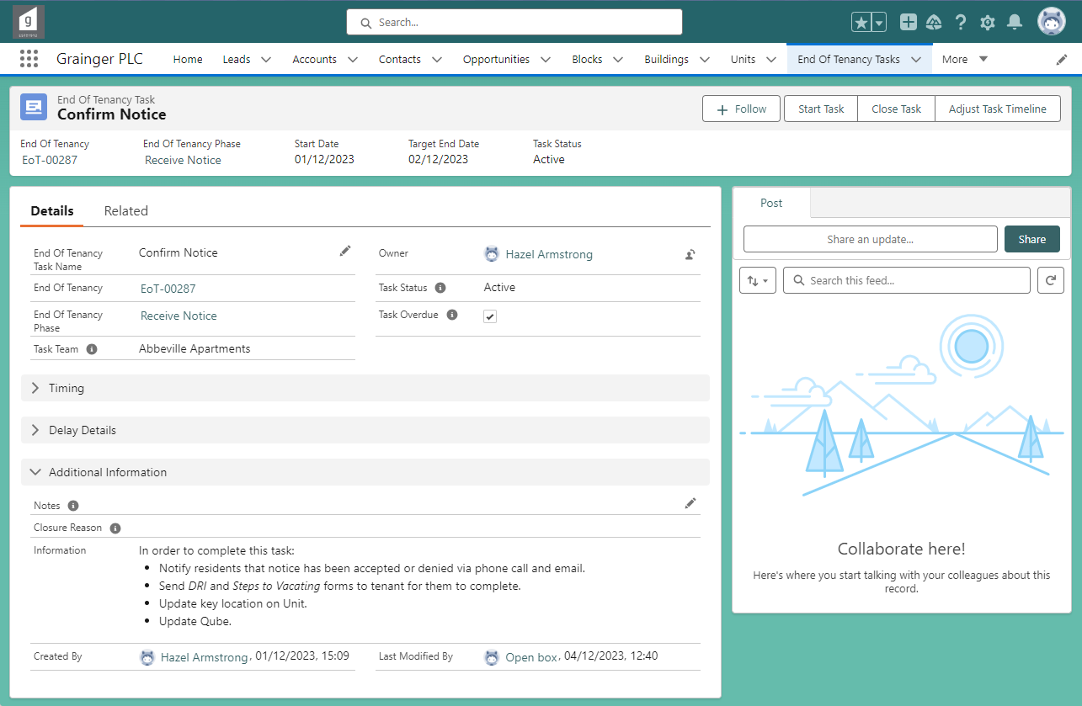
Files: Documents & emails can be linked to a task in the Related tab.
Information: Guidance on what needs to be done before the task can be marked as complete.
Notes: Capture any relevant notes about task progress; these may appear in reports.
Owner: Person responsible for completing the task.
Tasks are initially assigned to a task team and should be allocated to an individual as start date approaches.
A task’s Start Date and Target End Date will automatically update:
- Where a task is dependent on the Future Vacate Date or PVI Date, the task dates will automatically update when these dates changes.
- Where a task is dependent on other, prerequisite tasks being completed, the task dates will automatically update as the prerequisite tasks are completed or where any expected delays are captured.

Starting a Task
Select ‘Start Task’
If you have started working on a task, but it is not yet complete:

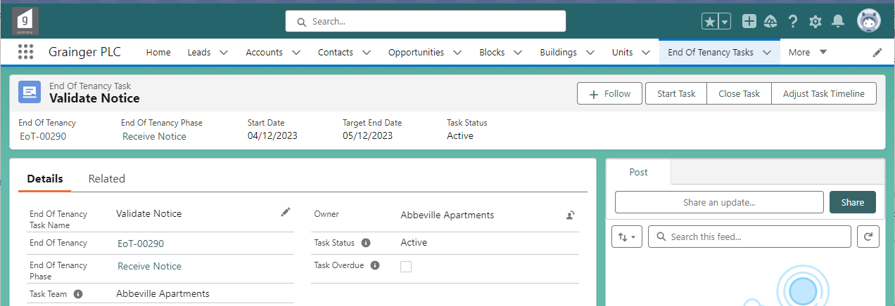
You will be automatically assigned as the task Owner
& the task status will be set to ‘In Progress’.

Completing a Task
Select ‘Close Task’
Once a task is complete:

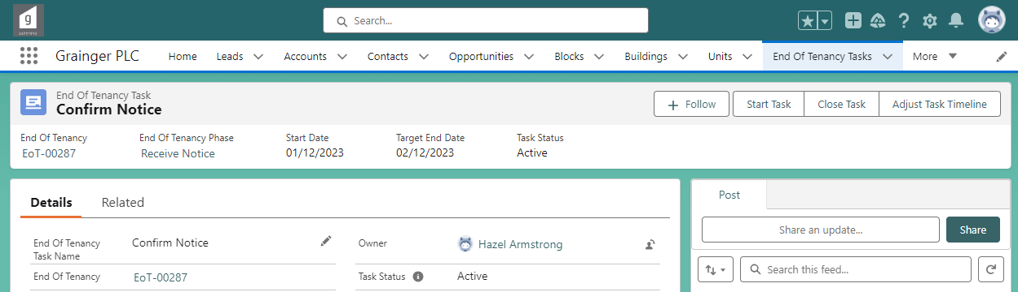
Select ‘Complete’, then ‘Next’.
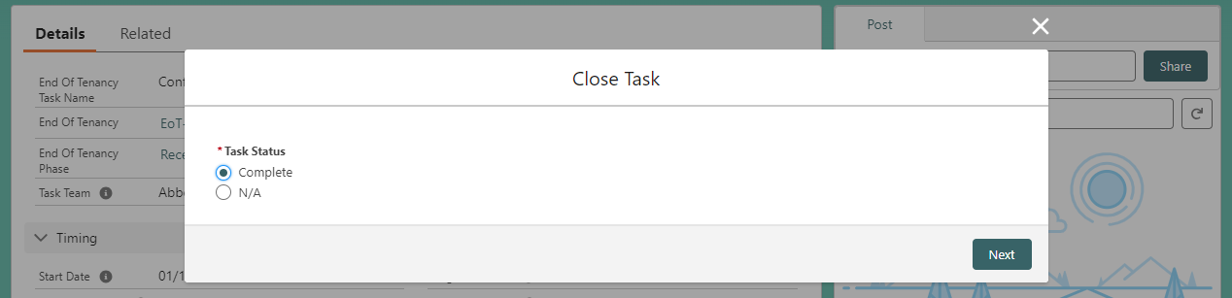
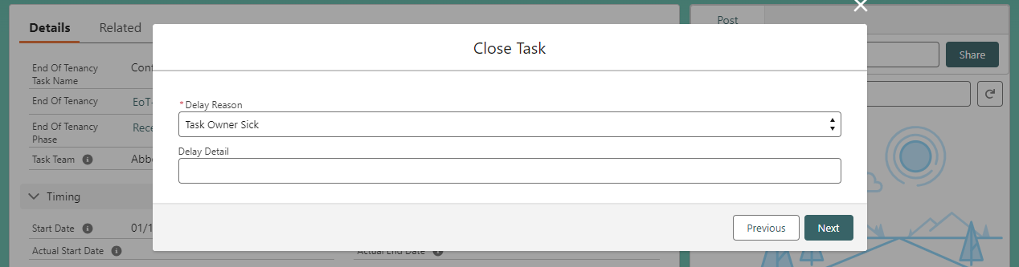
If the task is completed more than 2 days late (i.e. more than 2 days after Target Due Date), you will be required to enter a reason for the delay.

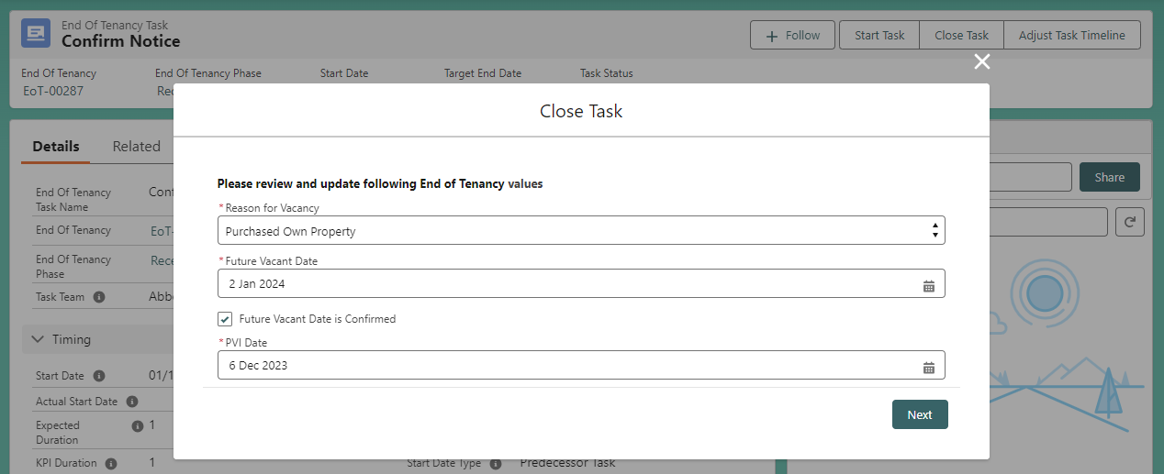
Certain tasks require specific End of Tenancy information to be reviewed & updated, as applicable, when closing the task.
You don’t need to start a task before completing it; active tasks can be set straight to complete.

Setting Tasks to N/A
Where a task is not relevant for a particular End of Tenancy, the task status can be set to ‘N/A’.
- N/A tasks are not included in the End of Tenancy timeline.
- For example, Approve Capex tasks may be set to ‘N/A’ if the refurb or refresh costs are below the threshold requiring approval.
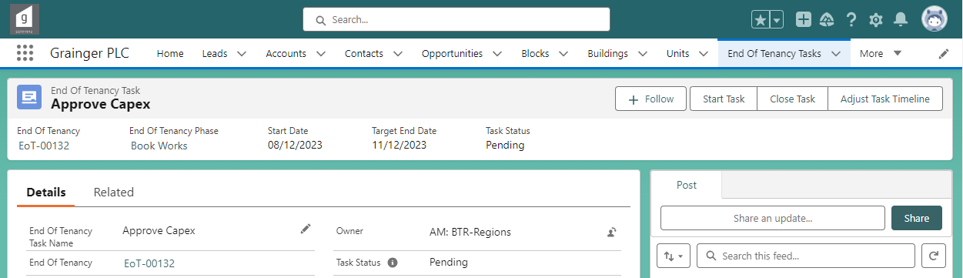
Select ‘Close Task’
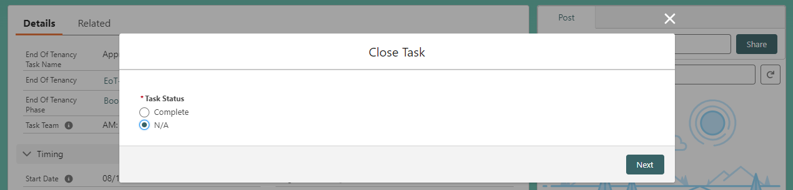
Select ‘N/A, then ‘Next’.
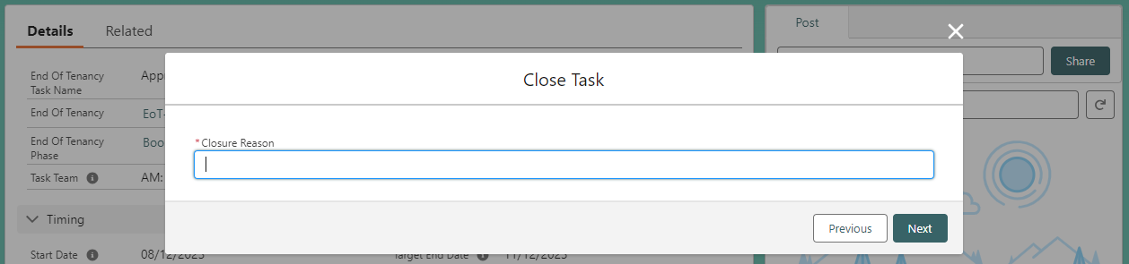
You will be required to enter a reason why the task is not appliable for the End of Tenancy.

Reopening a Closed Task
Select ‘Open Task’
If a task’s status was set to ‘Complete’ or ‘N/A’ by mistake:
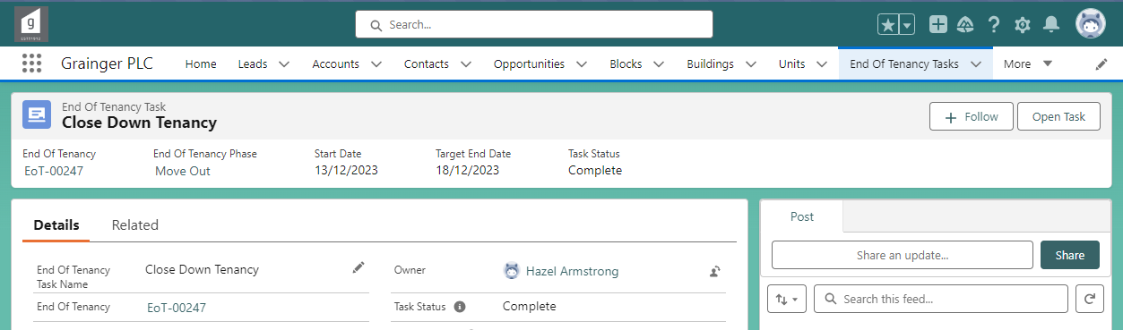
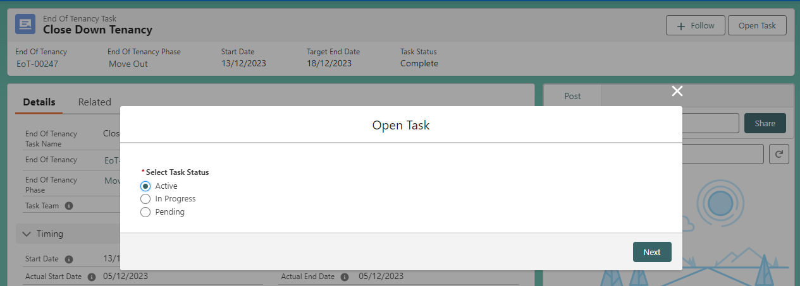
The task status will be updated on selecting ‘Next’.
Set the task back to the previous status.
See Task Statuses for more information.

Delays & Overdue Tasks
Expected delays - Expected delays can be captured & incorporated into estimated timeline.
Where there is a delay our completed more than 2 days past target end date -> reason & detail
Overdue & overdue days

Completed task
KPI duration

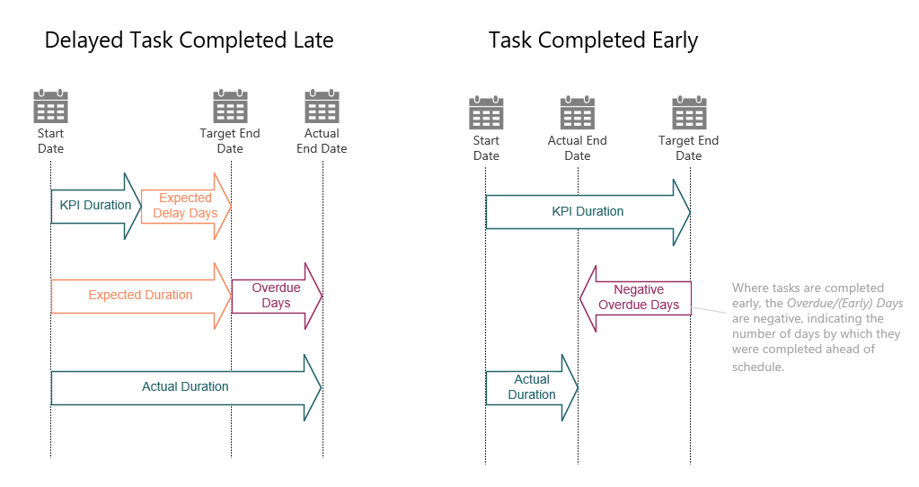

How to cancel or close an EOT

Reports
relevant to most end users.

Functionality for EOT owners:

Approving a request to cancel or close an EOT.

Identifying EOTs at risk

Void cost & KPI report.

